Project 2: Scripting the Interactor
Tzu-Wei Hsu, Lee Inman, and Jeanie Miskelly
April 19, 2004

Our project is an interactive game involving a portion of the storyline from the movie A Charlie Brown Christmas. It is not necessary for the user to be familiar with the actual movie, however, because the narrative of decorating a Christmas tree is a cultural convention that is almost universally understood in American culture, regardless of religious affiliation. In our game, the user must help Charlie Brown decorate his tree by Christmas Day. The state of the tree and the expression on Charlie Brown’s face cue the user as to his or her success in completing the task.

Design Goals | - Involve the user in the narrative of “A Charlie Brown Christmas”  - Allow the user to manipulate the environment by providing an interface which is clear and encourages play  - Show the user the result of his/her actions:  - A revived and well-decorated Christmas tree makes Charlie Brown happy  - A dead, bare Christmas tree makes Charlie Brown depressed

The stage is set for interaction by the introduction scene. Charlie Brown enters the stage, walks passed Snoopy’s dog house, and sees the pitiful tree, which won’t even hold one ornament. He says, “I feel depressed,” which cues the user to his unhappy state and sets the expectation that the user can do something to change it.

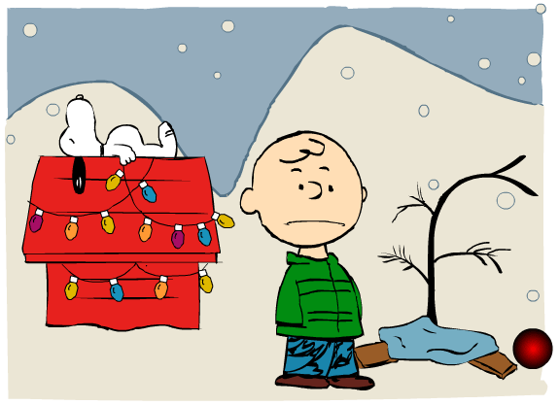
Figure 1: Charlie Brown shows the user he is depressed through sound and facial expression.
The next scene shows the same setting, but reveals the control panel, which has 4 buttons, an indicator, and a calendar.

Control Panel

Water Indicator | Shows the user the level of the water in the tree. Brown indicates that the tree needs water, green indicates that the tree has adequate water, and red indicates that the tree has been watered too much. The water level of the tree is constantly decreasing, as time passes.
Water Button | Allows the user to add water to the tree. When the user presses this button, he/she can see the results of the action in the Water Indicator
Ornaments Button | Allows the user to add ornaments to the tree.
Lights Button | Allows the user to add lights to the tree.
Popcorn Button | Allows the user to add strands of popcorn to the tree.
Calendar | Indicates the day and shows the user how close it is to Christmas.


Figure 2: Control Panel for Charlie Brown Christmas Game

User Interaction
Using the control panel, the user can interact with the tree and, through the tree, with Charlie Brown. The user must play the game to learn how to make the tree grow and what decorations can be added to the tree at which time. The buttons on the control panel are intentionally placed out of the order their respective decorations can be placed on the tree. This was done to encourage play and to make the game more challenging.

The tree has four states, and each successive state can hold more decorations. The way the tree grows from one state to the next is with adequate (but not too much) watering and the passage of time. The way the tree shrinks from one state to the previous is with too much watering, or not enough watering. Each time the tree shrinks to a lower state, decorations not permitted at the lower state fall off of the tree.

State 1 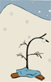 | tree cannot hold any decorations
State 2  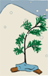 | tree can hold lights only (all other decorations fall off)  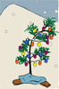
State 3  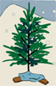 | tree can hold lights and ornaments ((all other decorations fall off)  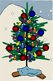
State 4  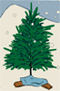 | tree can hold lights, ornaments, and popcorn.  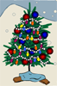

The following storyboard illustrates the tree growing with watering, and decorations being added, then falling off when watering is neglected:

Tree is in State 1 | 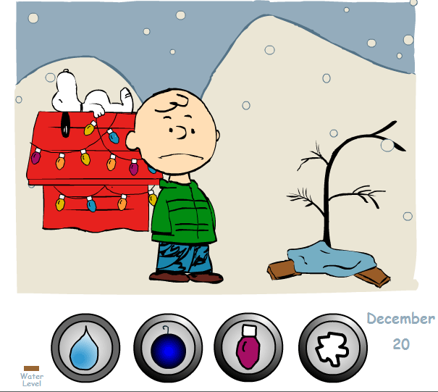
User waters tree, day increments by 1, | 
Tree grows to State 2, Charlie smiles | 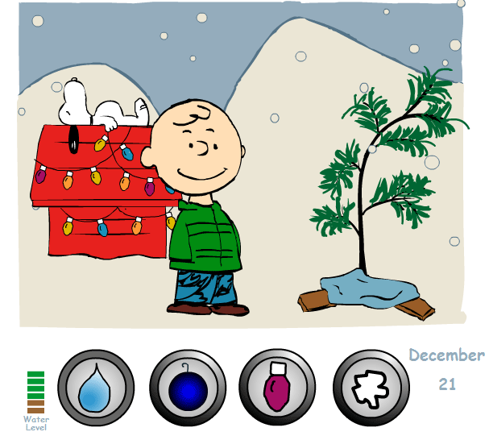
User adds lights to tree | 
Lights appear on tree | 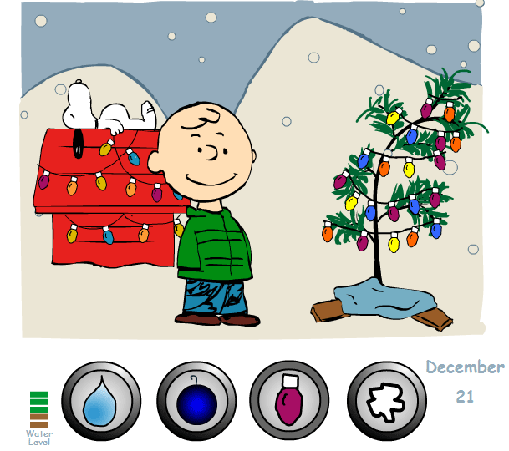
User neglects to water the tree, and it shrinks back to state 1; lights fall off and Charlie is upset | 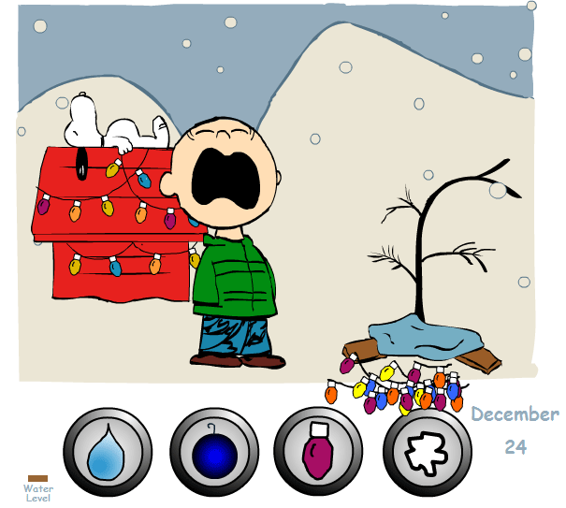

The user must add decorations to the tree in the proper order. The order for adding decorations is:
- lights
- ornaments
- popcorn

Character States
The tree is the main character in the game, with Charlie Brown as the secondary character. Lucy, Woodstock, and the group of skating children are peripheral characters.

As mentioned above, the tree can hold decorations based on its state. The user can add ornaments to any tree, with the following results:
Add decorations to a tree that cannot hold that particular decoration | Decorations added to the tree and immediately fall off
Add decoration[2] before decoration[1] | If the tree is in a state where it can accept lights and ornaments, and the user adds ornaments first, the ornaments will stay on the tree.  However, if the user then adds lights, the ornaments will fall off, and the lights will stay on.  The user can then add ornaments again.
Neglect watering, so that tree with decorations shrinks | Any decorations that are not supported by the state to which the tree shrinks will fall off.

The following diagram shows an internal representation of the Tree character:

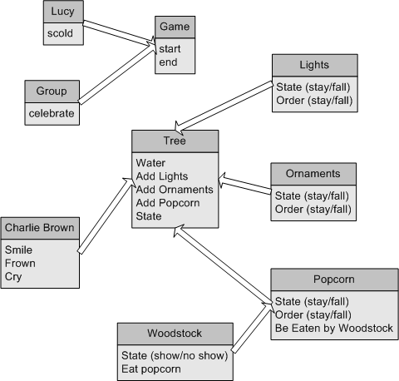
The diagram illustrates the internal state of each entity in the game. The lights, ornaments, and popcorn can all be added to the tree, and can fall off of the tree. The addition and the falling off of the lights, ornaments, and popcorn depend on the state of the tree. In addition, the popcorn can be eaten by Woodstock. Woodstock depends on the popcorn being visible on the tree, thus he can either show (when popcorn is on the tree) or not show (when popcorn is not on the tree). Woodstock can eat the popcorn when he is visible.

Charlie Brown depends on the state of the tree. His three expressions, smile, frown, and cry all depend on the state of the tree, and whether or not the tree has just shrunk.

Finally, Lucy and the group of skating children depend on the game. When the game ends, if the tree is fully decorated, the group of children skate by and sing “Merry Christmas Charlie Brown!” But if the game ends with the tree not completely decorated, Lucy scolds Charlie Brown. Both Lucy and the group depend on the game ending when the calendar reaches December 25th.

Character Functions
The characters of Woodstock and Lucy, who serve to foil and scold the interactor, respectively, have positive as well as negative impressions on the user. Woodstock flies onto the stage and eats the popcorn from the tree, causing the remaining popcorn to fall. However, the nature of Woodstock, as he flies through the air and turns a flip, is amusing. The interactor may actually hope Woodstock appears, just to see him fly by. Likewise, Lucy has an appealing aspect as well. Although she scolds Charlie Brown for messing up yet again, her admonishment is typical of her bossy nature, and is more likely to garner a laugh from the interactor than disappointment.

Conclusion
Through the use of appealing characters, cultural scripting, and interactive elements (in the form of buttons) our Charlie Brown Christmas game invites the interactor to play and gives visual and audible clues about the success or failure of the interactor’s actions.

In future versions of the game, there will be more challenges to decorating the tree on time. Snow may fall at random, obscuring the decorations and causing them to fall from the weight. However, the snow, when falling on a completely decorated tree in state 4 would augment the tree, and bring about an enthusiastic response from Charlie Brown. Wind and rain may come and blow the decorations off of the tree, but will increase the water level at the same time.

